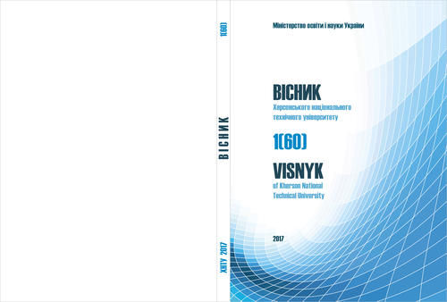 **Scientific journal "Bulletin of the Kherson**

**National Technical University"**

**ISSN** **2078 – 4481**

Kherson National Technical University

Ministry of Education and Science of Ukraine

73008, Beryslavske Highway, 24, Kherson, Ukraine

Tel.**.** +38(0552)32-69-07

**E-mail:** vestnikkntu@gmail.com

|  |  |  |
| --- | --- | --- |
|  | | |
| *reviewer:* |  |
| *organization:* |  |
| *e-mail:* |  |
| *5-10*  *keywords to describe your specialization / professional background* |  |

Dear ________________________,

We are sending you for review a manuscript of an article submitted to the editorial board of the scientific journal "Visnyk of Kherson National Technical University". Please return the article with the completed review form to the editorial board within two weeks.

The name of the reviewer is not disclosed.

**REVIEW OF ARTICLE MANUSCRIPTS**

**Article Manuscript Registration Number _________________________________________**

Year. Volume. Is (№). pages

**Title of the manuscript** **______________________________________________________________**

**______________________________________________________________**

**______________________________________________________________**

**Non-competing reviewer statement**: I declare that as a reviewer I have no competitive interest

Yes /No

**Plagiarism and Ethical Aspects:**

|  |  |
| --- | --- |
| Is there any ethical violation in this manuscript? |  |
| In case of suspected plagiarism, provide substantiated evidence or links to relevant resources |  |

|  |  |
| --- | --- |
| **Departure date**  **on review** **___________** | **Date received**  **reviews** **____________** |

**Title of the manuscript** **______________________________________________________________**

**______________________________________________________________**

**Evaluation of the quality and scientific level of the article**

|  |  |  |
| --- | --- | --- |
| **Criteria for evaluating a manuscript** | **Article Degree of compliance with the criterion** | |
| **Yes** | **No** |
| 1. Does the article fit the topic of the Journal? |  |  |
| 2. Does the article meet the requirements of the Journal? |  |  |
| 3. Are the manuscript materials new and original? |  |  |
| 4. Does the title of the article correspond to its content, chosen research approaches, goals, objectives and summary? |  |  |
| 5. Is the presentation of the article material consistent and logical? |  |  |
| 6. Does the language of the manuscript comply with existing literary standards? |  |  |
| 7. Is the volume of the article rationally used and is the list of literature sources up to date? |  |  |
| 8. Are the conclusions of the study and their scientific novelty justified? |  |  |
| 9. Is the article material representative and are the techniques appropriate to the tasks set? |  |  |
| 10. Are the mathematical calculations, graphs, drawings, tables correct? |  |  |
| 11. Is the technical quality of the graphic material (if any) satisfactory? |  |  |
| 12. Is the contribution to solving the problem under consideration disclosed and justified? |  |  |

**Overall score**

|  |  |
| --- | --- |
| A - The article may be published in the Journal without further elaboration by the author |  |
| B - The article may be published in the Journal, but with little revision |  |
| C - The article may be published in the Journal, but with considerable revision |  |
| D - The article cannot be printed in the Journal |  |

|  |
| --- |
| **Reviewer comment:**  - relevance of the article to the topic of the Journal, relevance;  - characteristic of originality and scientific novelty;  - characterization of expediency of use of the chosen research methods;  - description of existing comments, reviewer's recommendations, advice on prospects for development and improvement of the study described in the article;  - a final comment on the possibility of publishing the material of the article, indicating the nature and nature of the necessary revisions. |

Reviewer's signature *_________________* Date of review completion _________________